
B.Tech. II CSE PROGRAM
A.Y.2025-26 ODD, Semester-III
24MT2012- Mathematical Optimization
Home assignment for CO1

Topic: Graphical Method, Simplex Method

Rubric for Assignment Evaluation:

Evaluation  Parameters | Description | Max  Marks | Actual Marks
Content | 1. Demonstrates a clear understanding of the topic and addresses all aspects of the assignment.  2. Provides relevant and accurate information, supported by evidence or examples. | 5
Structure and  Organization | 1. Has a clear introduction that sets the context and purpose of the assignment.  2. Use appropriate headings, subheadings, or paragraphs to organize ideas. | 2
Language &  Style | 1. Employs clear and concise language, free from grammatical and spelling errors.  2. Use appropriate vocabulary and terminology for the subject matter. | 2
Presentation &  Formatting | 1. Adheres to the specified formatting guidelines (e.g., font, margins, spacing).  2. Presents the assignment in a neat and visually appealing manner. | 1
Total Marks |  | 10

Problem 1
Case Study 1:
Consider a manufacturing facility with 4 tasks and 3 machines. The processing times and machine capacities are as follows:
Processing times:
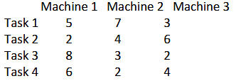
Machine capacities:
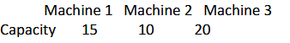
Minimize the total completion time. write Python code to solve this optimization problem using the PuLP library.

Problem 2
Case Study 2:
Consider a scenario where there are 3 suppliers and 4 consumers. The transportation costs from each supplier to each consumer are as follows:
Transportation Costs :
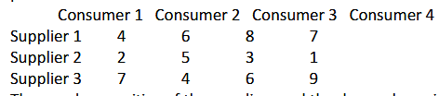
The supply capacities of the suppliers and the demand requirements of the consumers are as follows:
Capacities and Demands:
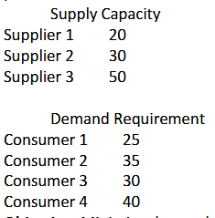
Minimize the total transportation cost. write Python code to solve this transportation logistics problem.
Problem 3
Case Study 3:
Solve the following problem using Simplex method
Subject to

Signature of Course Coordinator

